Docker : <https://www.docker.com/products/docker-desktop/>

SonarScanner : [https://binaries.sonarsource.com/Distribution/sonar-scanner-cli/sonar-scanner-cli-5.0.1.3006-windows.zip?_gl=1*2o3bc*_gcl_au*MTMxOTIwNDg3Ni4xNzAwOTIzNTEz*_ga*OTU0NTc2ODUuMTcwMDkyMzUxMw..*_ga_9JZ0GZ5TC6*MTcwMjkxMTU1My40LjAuMTcwMjkxMTU1My42MC4wLjA](https://binaries.sonarsource.com/Distribution/sonar-scanner-cli/sonar-scanner-cli-5.0.1.3006-windows.zip?_gl=1*2o3bc*_gcl_au*MTMxOTIwNDg3Ni4xNzAwOTIzNTEz*_ga*OTU0NTc2ODUuMTcwMDkyMzUxMw..*_ga_9JZ0GZ5TC6*MTcwMjkxMTU1My40LjAuMTcwMjkxMTU1My42MC4wLjA).

Add **sonar-scanner-5.0.1.3006-windows/bin** to Environment Variables.

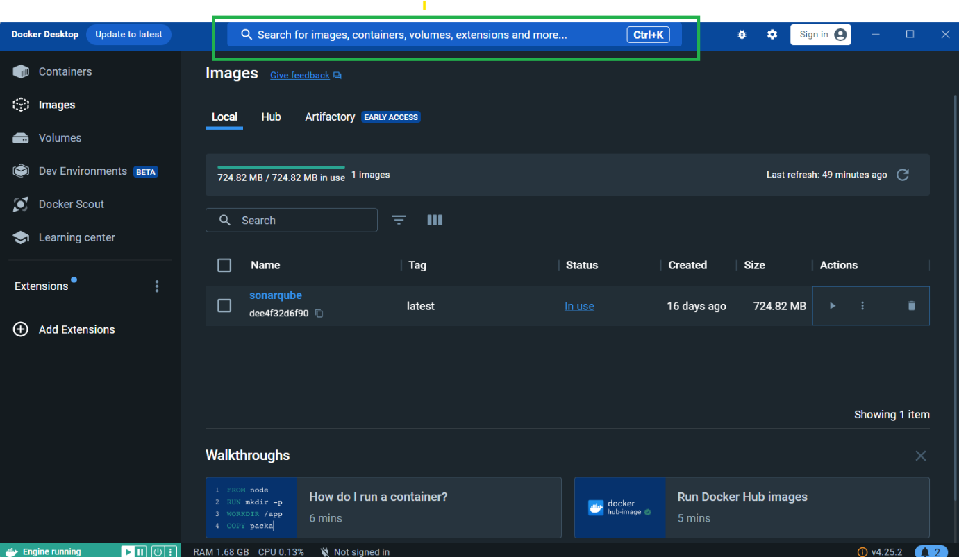

Search for sonarqube

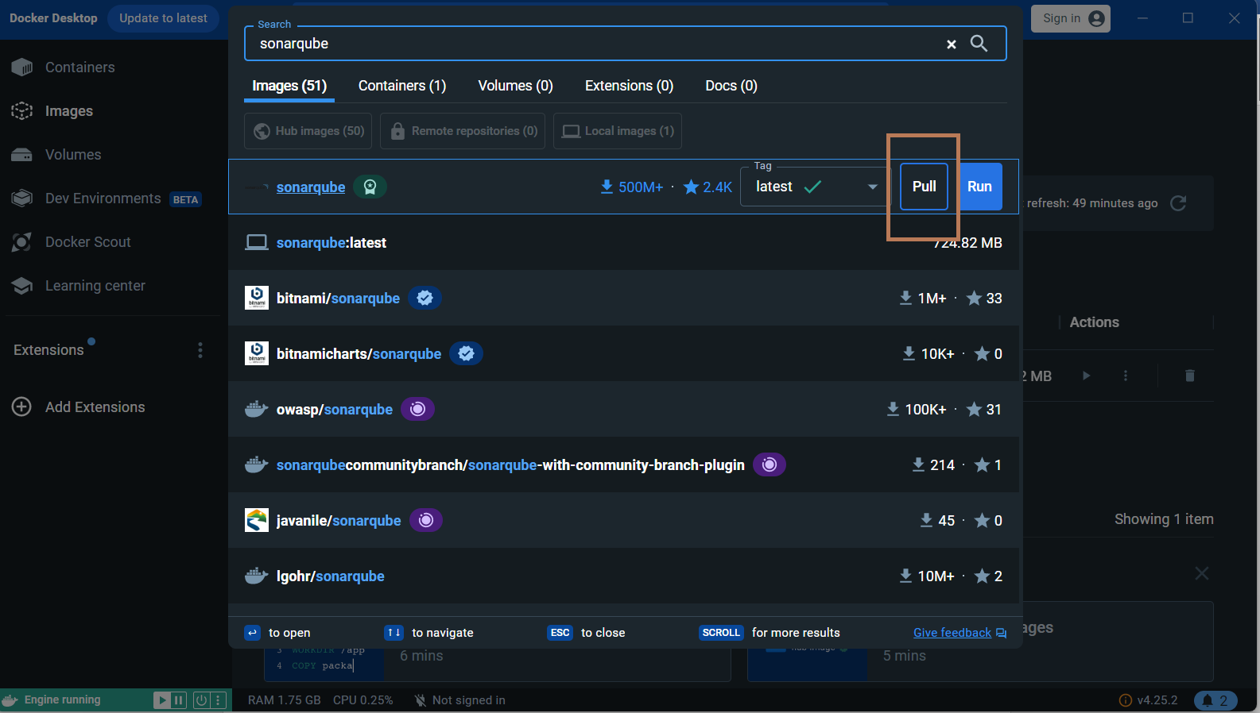

Pull Sonarqube

Open Command Prompt:

**docker -v**

**docker run -d --name sonarqube -p 9000:9000 -p 9092:9092 sonarqube**

Move to Containers tab, Click Start sonarqube

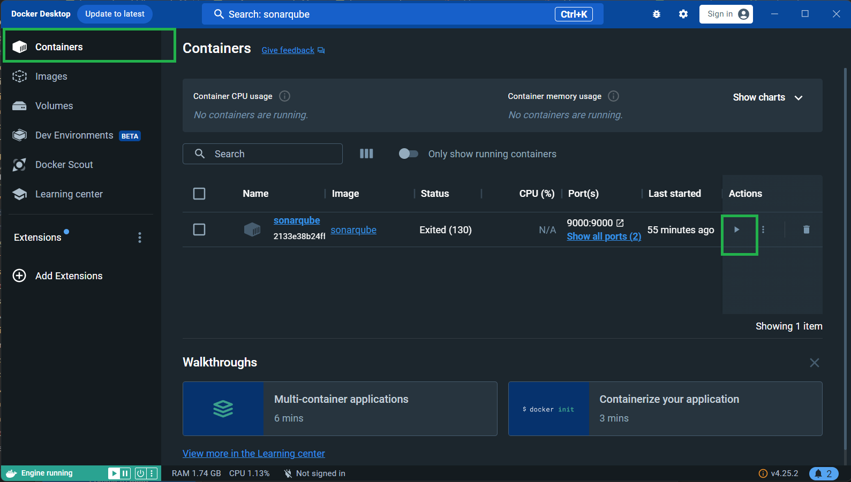

Click on Port 9000:9000 -

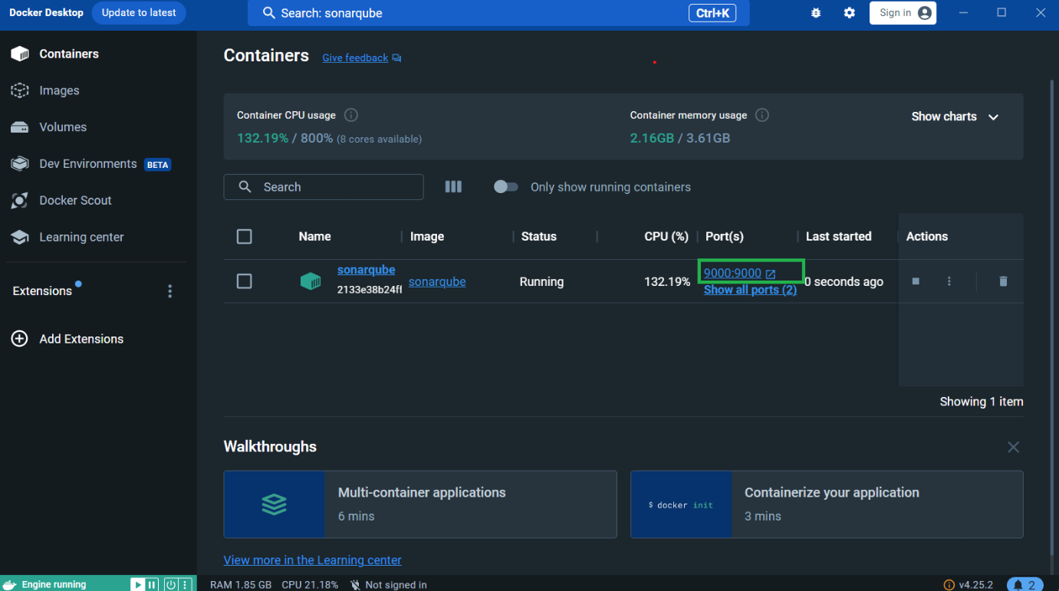

For first time users:

Username: admin

Password: admin

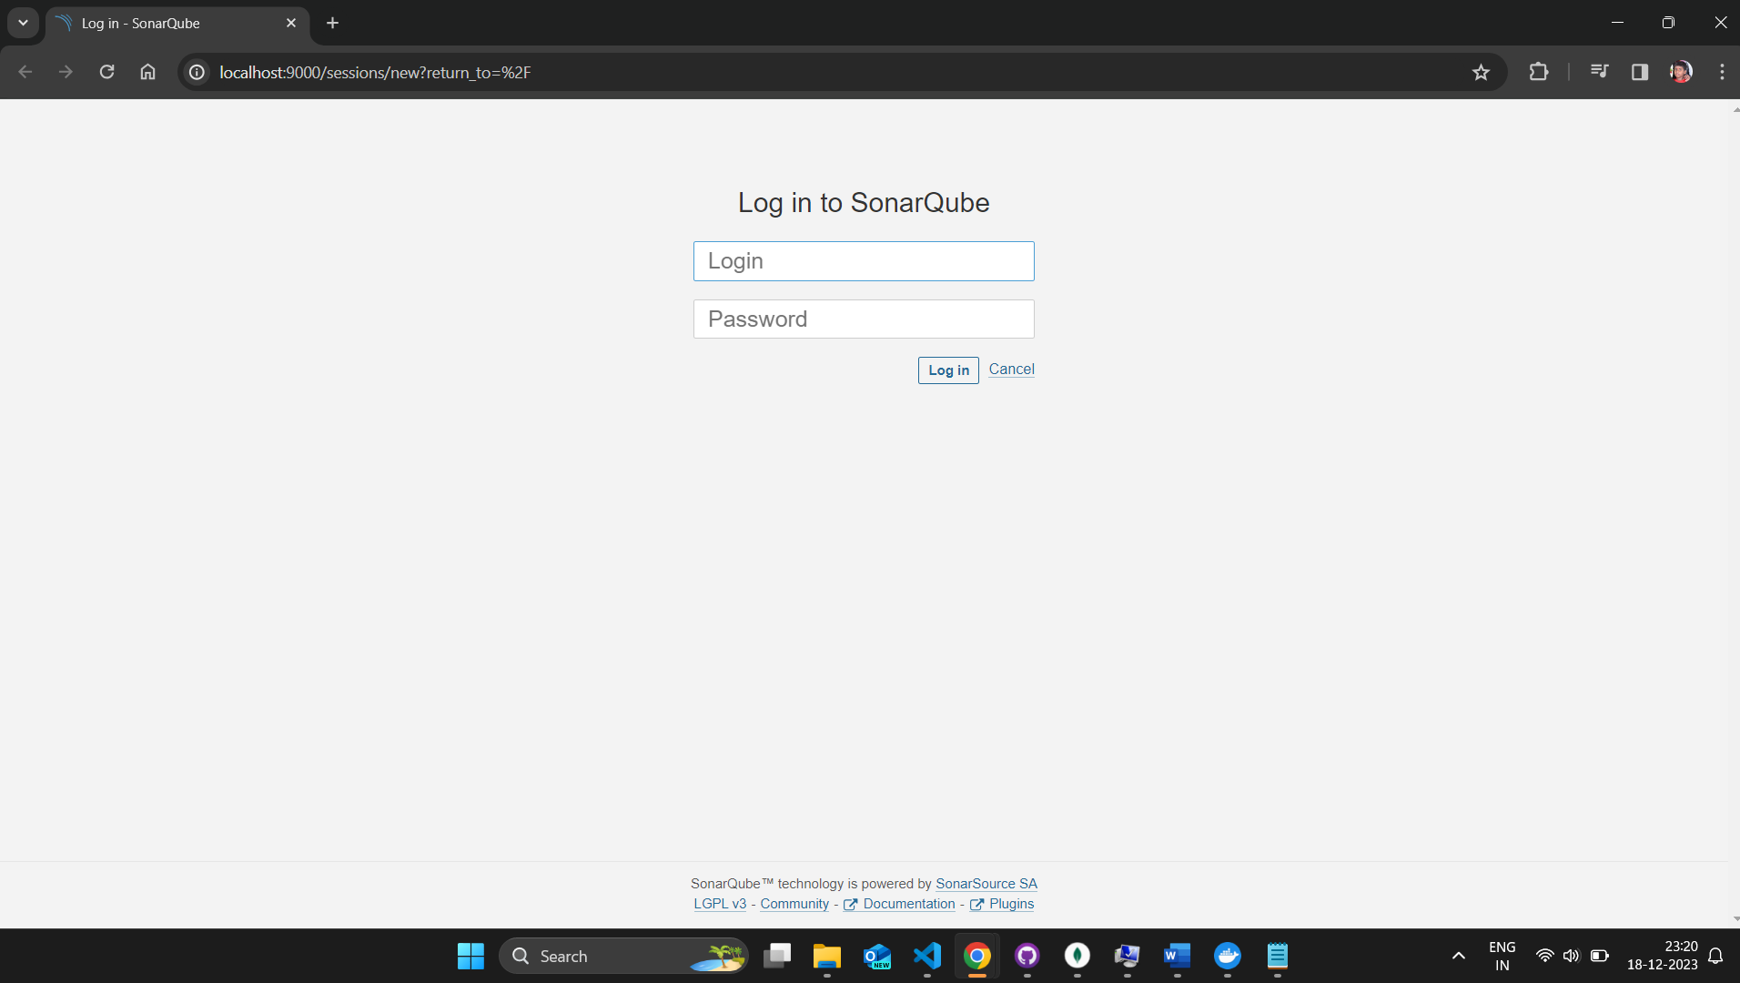

Create a local project

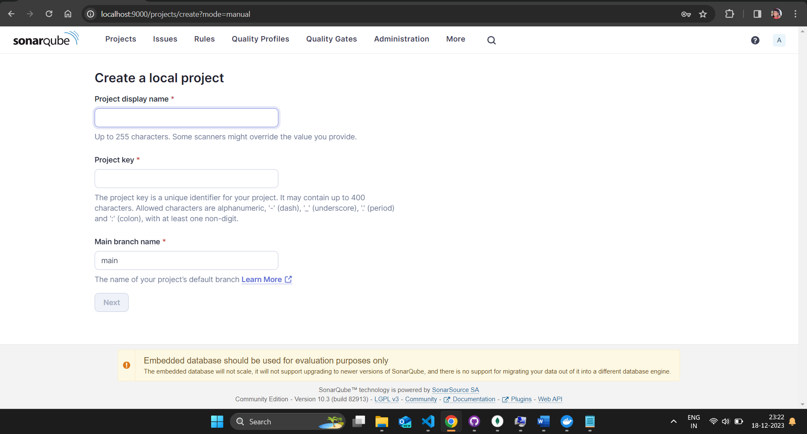

Use the global setting, Create a project.

Click locally

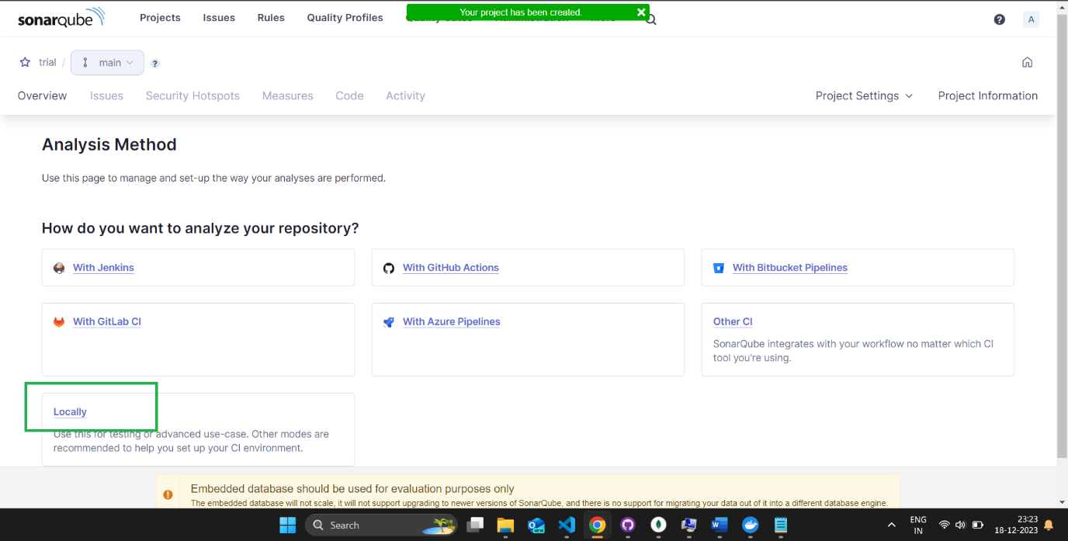

Click Generate

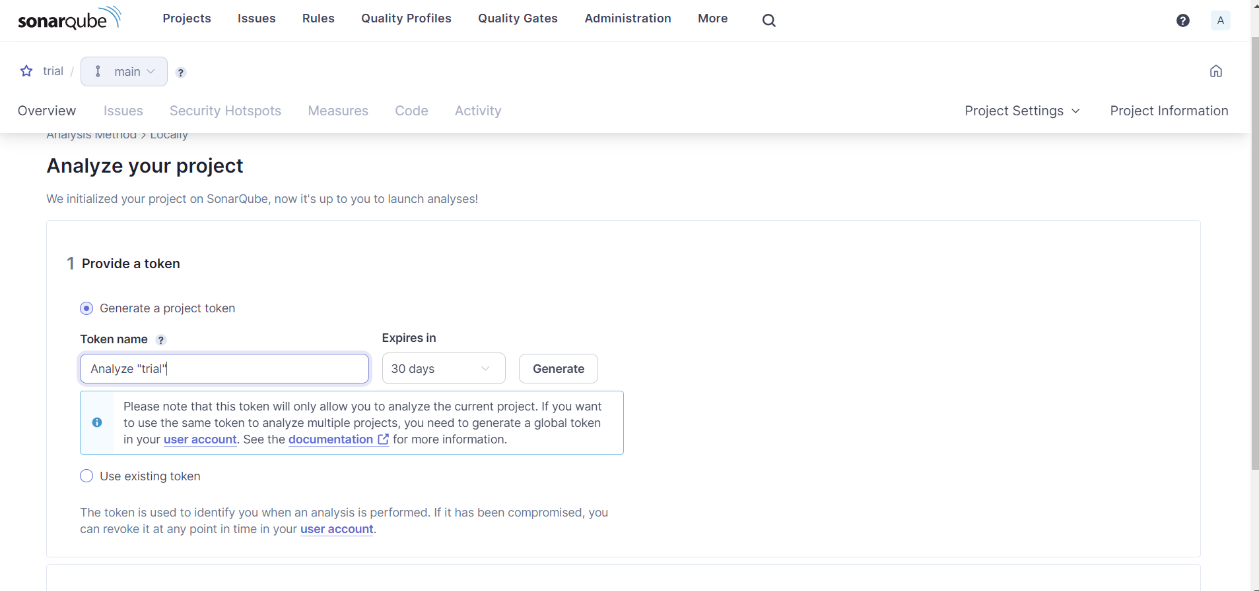

And click continue.

Choose – Other(for Js,..) Then Choose Windows

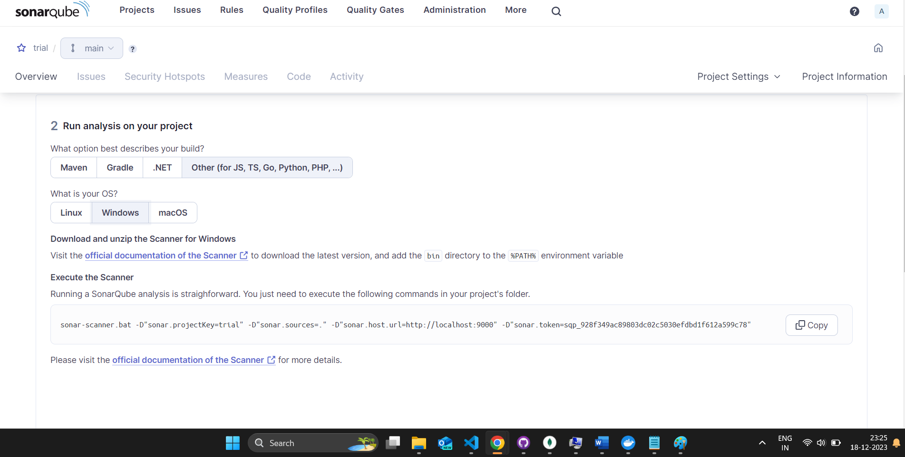

Copy the command and run it in **REC-CTS-DN-Reverence-FEP\server**  -directory

After Completion, Same webpage will reload automatically and shows the test result